
ARIZONA SUPREME COURT
Administrative Office of the Courts
JUDICIAL EDUCATION CENTER (JEC)
3003 N. Central Avenue, Suite 500
Phoenix, AZ 85012
602.452.3060

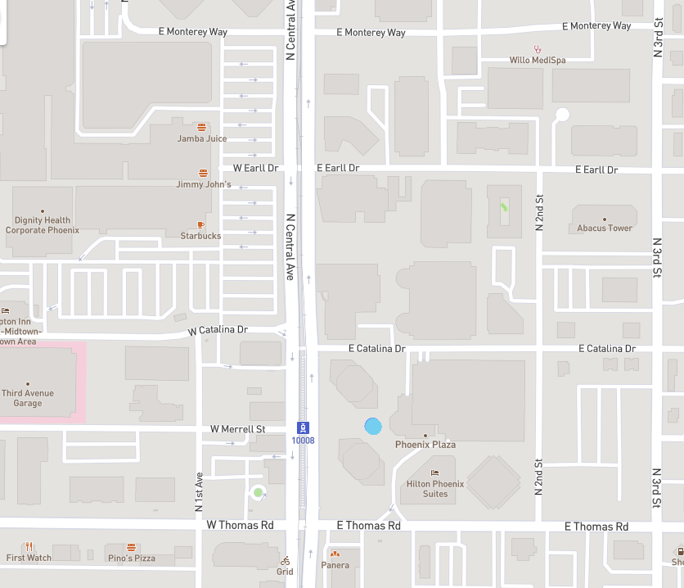
Enter parking garages from East Catalina Drive or East Earll Drive through the “visitors” entrance.

Please bring your parking ticket into Judicial Education Center for validation.
Hilton Garden Inn
(North on Central 0.8 miles from JEC)
Visitor Parking
Hampton Inn
Embassy Suites
JEC
5th Floor
Visitor Parking
Park Central Mall

